1.Interface elements description

1. Ribbon tabs - ribbon tab I a tab that contains the organized commands.
2. Ribbon - commands under the tabs .
3. Ribbon groups - grouping of related commands.
4. Dialog box - opens a dialog box that includes additional commands .
5. Quick access toolbar - one click access to any frequently used command .
6. Name box - Displays cell location and can be used to navigate to a cell location .
7. Select all btn - select all the cells in the worksheet.
8. Formula bar - view, enter and edit cell contents.
9. Insert function btn - displays insert function dialog box.
10. Scroll bars - used to navigate up, down, left and right.
11. Zoom slider - zoom into an area of the worksheet.
12. View buttons - switch between normal, page layout and page break preview views
13. Worksheet tabs - this tabs used to select the individual worksheet
14. The workspace - the area inside of column and row used in excel
15. Column - column use letters.
16. Row - row use numbers.
17. various applications of excel in the industry are bellow
18. Calculation.
19. Accounting
20. Charting
21. Inventory tracking
22. Calenders and schedules
23. Seating chart
24. Goal planning worksheet
25. Mock-ups
26. Task list
27. Checklist etc.

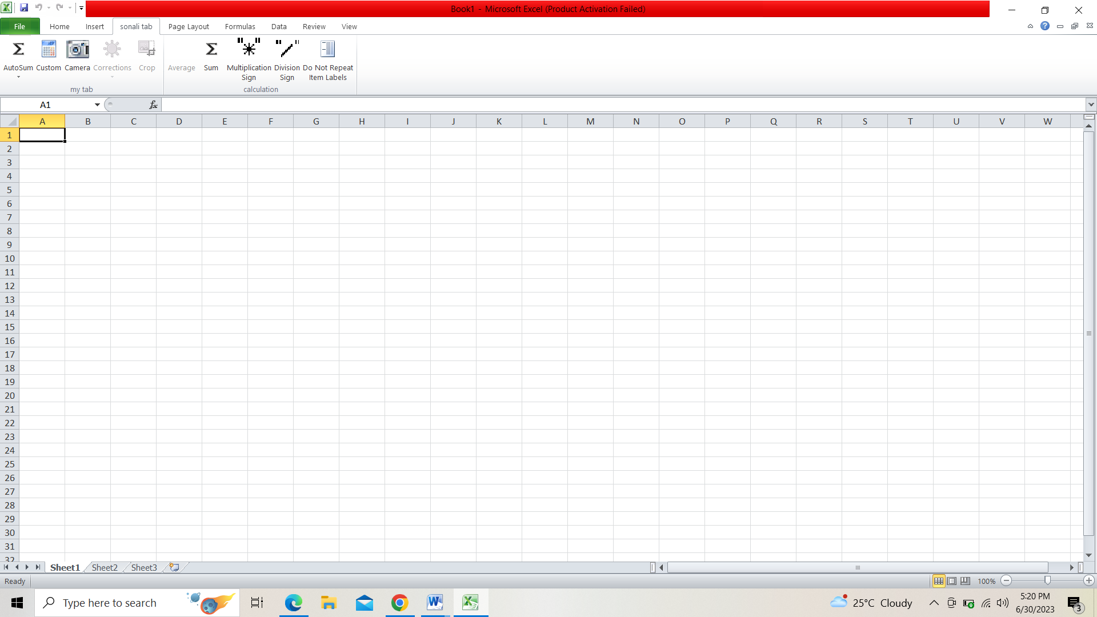

1. Shortcut keys are
2. Alt + F: File menu options in current program.

b. Alt + E: Edit options in current program

c. F1: Universal Help in almost every Windows program.

d. Ctrl + A: Select all text.

e. Ctrl + X: Cut

f. Shift + Del: Cut selected item.

g. Ctrl + C: Copy selected item.

h. Ctrl + Ins: Copy selected item.

i. Ctrl + V: Paste selected item.

j. Shift + Ins: Paste.

k. Home: Goes to beginning of current line.

l. Ctrl + Home: Goes to beginning of document.

m. End: Goes to end of current line.

n. Ctrl + End: Goes to end of document.

o. Shift + Home: Highlights from current position to beginning of line.

p. Shift + End: Highlights from current position to end of line.

q. Ctrl + Left arrow: Moves one word to the left at a time.

r. Ctrl + Right arrow: Moves one word to the right at a time.

1. data will use the range of formulas to unlock the potential of data.data will be present each row and column.in this way data will be filtered and sorted and hence displayed in a presentable manner and it is jam packed with features and functions that can be used to clean, aggregate, pivot and graph data

